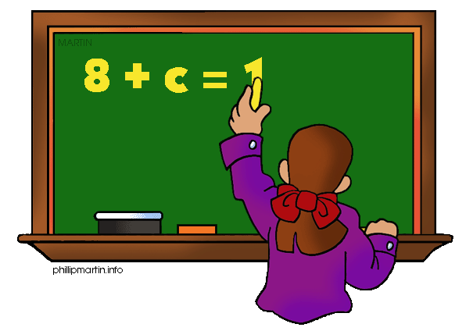

What we are learning about: Unit 1 Operations with Rational Numbers

One way you can help your student succeed in the unit is by discussing the lesson targets in the chart below. When a lesson is completed, ask your student the following questions:
- What are the targets (goals) of the lesson?
- What new words and formulas did you learn?
- How can you apply the ideas of the lesson to your life?

Target | Examples | Key Vocabulary
Multiply and Dividing Integers  Chapter 3 Section 4 & 5 | -2 x 4= -8 -4 x -5 = 20  -16/ 2 = -8 -36/ -9 = 4  Two negatives turn into a positive.  One negative and one positive stays negative. | - Product  - Integer  - Negative Integer  - Positive Integer  - Quotient  - Order of Operations
Absolute Value  Chapter 3 Section 1 | ⎸-5⎹ = 5  ⎹⎸6 ⎹= 6  It is the distance a number is away from zero. | - Absolute Value
Adding and Subtracting Integers  Chapter 3 Section 2 and Section 3 | -4 + -4 = -8  5+ -2 = 3  5-( -2) = 7  -10 – (-3) = -7  -10 – 3 = -13 | - Zero Pair  - Opposite  - Sum  - Difference  Rhyme we use for addition: Same sign, add and keep different sign, subtract take the sign of the bigger number then it will be exact  Change subtraction to addition- Add a line change the sign
Adding and Subtracting Fractions  Chapter 4 Section 3, 4 and 5 | $\frac{1}{2}- \frac{-3}{8}$= $\frac{7}{8}$  $\frac{-7}{12}$ + $\frac{1}{4}$ =$\frac{-4}{ 12}= \frac{-1}{3}$ | - Rational Number  - Irrational Number  - Fraction  - Like Fraction  - Common Denominator  - Numerator  - Denominator
Multiply and Dividing Fractions  Chapter 4 Section 6 and 8 | $\frac{-1}{5} X \frac{4}{7}$ ⁼ $\frac{-4}{35}$  $$\frac{-5}{8} ÷ \frac{1}{2}turns into$$  $\frac{-5}{8} X \frac{2}{1}$⁼ $\frac{-10}{8}$ | - Simplify  - Mixed Number  - Improper Fraction  - Reciprocal  - Numerator  - Denominator

If you or your students have any questions about the unit or math class, feel free to contact me at hummelcl@qps.org or call 217-223-0373 Extension 1309

