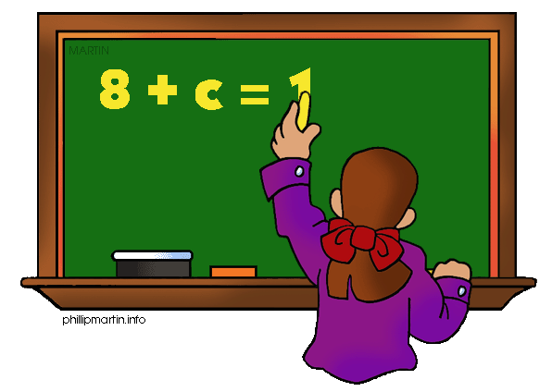
Parents as Partners
Algebra 1

What we are learning about: Unit 1 Linear Equations and Inequalities

One way you can help your student succeed in the unit is by discussing the lesson targets in the chart below. When a lesson is completed, ask your student the following questions:
- What are the targets (goals) of the lesson?
- What new words and formulas did you learn?
- How can you apply the ideas of the lesson to your life?

Target | Examples | Key Vocabulary
Writing Verbal Phrases  Chapter 1 Section 1 | Two more than a number is 24  X+2=24 | - Verbal Phrase  - Words on Chart that tell you the four operations-X, /, +, -
Solving One Step Equations  Chapter 1 Section 8 | X+5=8  -5 -5  X=3  All operations, x, /, +, - | - Equation  - Solution of  equation  - Formula
Solving Two-step Equations  Chapter 2 Section 1 and 2 | 2x + 3 = 9  -3 = -3  2x = 6  $\frac{2x}{2}$ = $\frac{6}{2}$  X = 3 | - Two-step equation  - Coefficient  - Additive inverse  Inverse operation
Solving Multi step Equations  Chapter 2 Section 3 | 2x+5x+3=31  7x+3=31  -3 -3  7x=28  ÷7 ÷7  X=4 | - Like terms  - Distributive Property  - Reciprocal  - Inverse operation
Solving Equations with Variables on Both sides  Chapter 2 Section 4 | 5x+3=4x+8  -4x -4x  1x+3= 8  -3 -3  X= 5 | - Like terms  - Inverse operation  - Solution
Solving Literal Equations  Chapter 2 Section 5 | Solve for V  2v+x=l  -x -x  2v=l-x  ÷2 ÷2  V=(l-x)/2 | - Literal equation  - Inverse operation
Solving One Step inequalities  Chapter 3 Section 2 and 3 | x + 5 > 10  -5 > -5  X > 5  All operations, x, / , +, - | - Inequality  - Solution of an Inequality  - Graphing solutions  - Quotient  - Product  - Sum  - Difference  - Word for inequality symbol-chart in notes  - Open and closed circles
Solving Multi Step Inequalities  Chapter 3 Section 4 | 5(b+6) < 5b +45  5b+30 < 5b + 45  -5b -5b  30<45  All Real Numbers are Solutions | - Inequality  - Solution  - All Real Numbers  - No Solutions  - Distributive Property  - Like Terms  - Inverse Operation

If you or your students have any questions about the unit or math class, feel free to contact me at hummelcl@qps.org or call 217-223-0373 Extension 1309

