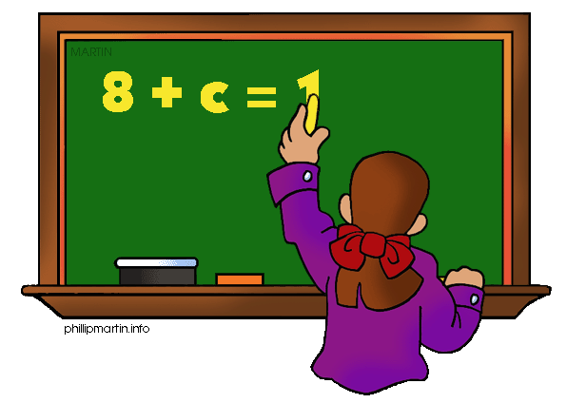

What are we learning about Unit 2: Ratios and Proportional Reasoning and Relationships

One way you can help your student succeed in the unit is by discussing the lesson targets in the chart below. When a lesson is completed, ask your student the following questions:
- What are the targets (goals) of the lesson?
- What new words and formulas did you learn?
- How can you apply the ideas of the lesson to your life?

Target | Examples | Key Vocabulary
Ratios  Chapter 1 Section 1 | In a classroom of 30 there are 12 girls and 18 boys.  Example ratios:  18 boys: 12 girls  12 girls: 30 students  18 boys: 30 students | - Ratio  - Equivalent Ratios
Unit Rates  Chapter 1 Section 1 | A six pack of Pepsi cost $4.68. The unit rate for one can of Pepsi is $4.68/6= $0.78/ 1 can | - Rate  - Unit Rate
Identifying Proportional Relationships  Chapter 1 Section 4 and 5 | Tables: Change by same rate  Hours 1 2 3  Money $15 $30 $45  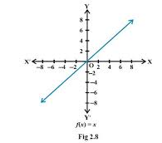  Graphs: Goes through the origin and is a straight line | - Constant of proportionality  - Origin  - Proportional  - Non-proportional  - Equivalent Ratios
Proportions  Chapter 1 Section 6 | $$\frac{5}{6}=\frac{t}{18} t=3$$  5 x 18= t x 6  90 = 6t, then divide by 6  t=15 | - Proportion  - Cross product

If you or your students have any questions about the unit or math class, feel free to contact me at hummelcl@qps.org or call 217-223-0373 Extension 1309

