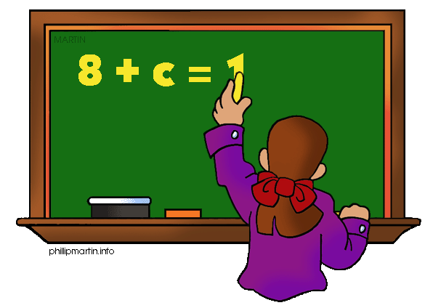
Parents as Partners
Algebra 1

What we are learning about: Unit 2 Functions & Linear Functions

One way you can help your student succeed in the unit is by discussing the lesson targets in the chart below. When a lesson is completed, ask your student the following questions:
- What are the targets (goals) of the lesson?
- What new words and formulas did you learn?
- How can you apply the ideas of the lesson to your life?

Target | Examples | Key Vocabulary
Writing and Identifying Functions  Chapter 4 Section 1 | 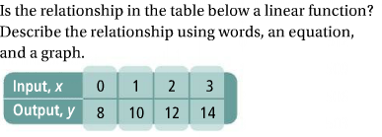 | - Independent Variable  - Dependent Variable  - Function  - Linear function
Using a T-table to graph functions  Chapter 4 Section 5 | Graph the function y= -3x +1 with the domain -2 ≤ X ≤ 2. Then identify the restrictions for the range.  X -2 -1 0 1 2  y 7 4 1 -2 -5 | - Domain  - Range  - Restrictions  - T-table
Using X and Y intercepts to graph a function  Chapter 5 Section 5 | 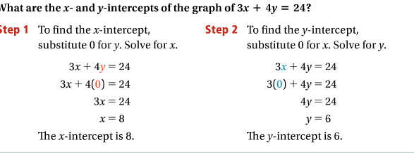 | - X-intercept  - Y-intercept  - Standard Form
Finding Slope and Rate of Change  Chapter 5 Section 1 | 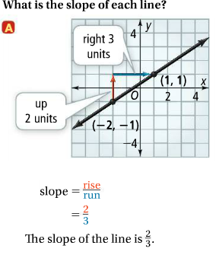 | - Rate of Change  - Slope  - Y-coordinate  - X-coordinate
Writing Equations in Slope Intercept Form  Chapter 5 Section 3 | 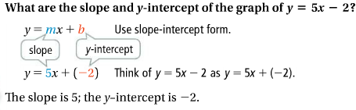 | - Slope intercept form  - Y-intercept  - Slope
Writing Equations in Point-Slope Form  Chapter 5 Section 4 | 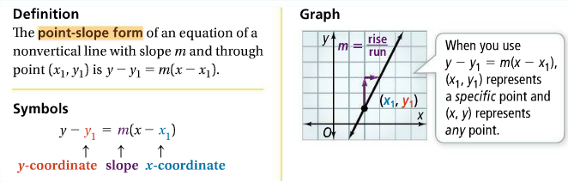 | - Point Slope Form  - Y coordinate  - Slope  - X coordinate

If you or your students have any questions about the unit or math class, feel free to contact me at hummelcl@qps.org or call 217-223-0373 Extension 1309

