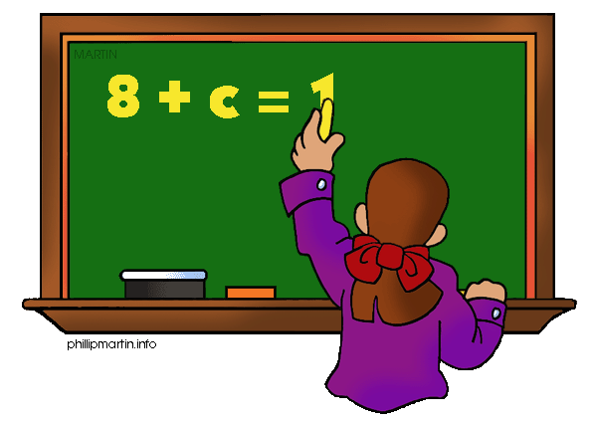

What are we learning about Unit 3: Equations and Expressions?

One way you can help your student succeed in the unit is by discussing the lesson targets in the chart below. When a lesson is completed, ask your student the following questions:
- What are the targets (goals) of the lesson?
- What new words and formulas did you learn?
- How can you apply the ideas of the lesson to your life?

Target | Examples | Key Vocabulary
The Distributive Property  Chapter 5, Lesson 4 | $2($90+6x)= 2(90)+ 2(6x)  180 + 12x | - Distributive Property  - Expression  - Variable
Simplifying Variable Expressions  Chapter 5, Lesson 5 | 5x+ 4x+7+8  5x and 4x are like terms  7 and 8 are like terms  Add the like terms to get:  9x+15 | - Terms  - Coefficient  - Constant term  - Like terms  - Expression
Solving Addition and Subtraction Equations  Chapter 6 Lesson 1 | X+5=8  -5 -5  X=3 | - Variable  - Inverse operation  - Solution  - Sum  - Difference
Solving Multiplication and Division Equations  Chapter 6 Lesson 2 | 20=4x  $\frac{20}{4}$ = $\frac{4x}{4}$  5=x | - Formula  - Inverse operation  - Coefficient  - Variable  - Solution  - Quotient  - Product

Solving Two Step Equations  Chapter 6 Lesson 4 and 5 | 2x + 3 = 9  -3 = -3  2x = 6  $\frac{2x}{2}$ = $\frac{6}{2}$  X = 3 | - Two-step equation  - Coefficient  - Additive inverse  - Inverse operation
Solving Inequalities Using Addition or Subtraction  Chapter 6 Lesson 6 | x + 5 > 10  -5 > -5  X > 5 | - Inequality  - Solution of an Inequality  - Equivalent inequalities  - Sum  - Difference  - Word for inequality symbol-chart in notes  - Open and closed circles
Solving Inequalities Using Division or Multiplication  Chapter 6, Lesson 7 | 5x > 10  ÷5 ÷5  x > 2 | - Inequality  - Solution of an Inequality  - Graphing solutions  - Quotient  - Product  - Word for inequality symbol-chart in notes  - Open and closed circles
Solving Two Step Inequalities  Chapter 6 Lesson 8 | 5x + 6 > 21  -6 -6  5x >15  ÷5 ÷5  X >3 | - Inequality  - Solution of an Inequality  - Two-Step inequality  - Word for inequality symbol-chart in notes  - Open and closed circles

If you or your student have any questions about the unit or math class, feel free to contact me at hummelcl@qps.org or call (217) 222-3073 Ext.1309

