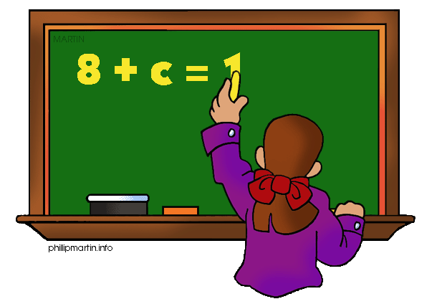
Parents as Partners
Algebra 1

What we are learning about: Unit 3 Data Correlation

One way you can help your student succeed in the unit is by discussing the lesson targets in the chart below. When a lesson is completed, ask your student the following questions:
- What are the targets (goals) of the lesson?
- What new words and formulas did you learn?
- How can you apply the ideas of the lesson to your life?

Target | Examples | Key Vocabulary
Frequency Tables and Histograms  Chapter 12 Section 2 | 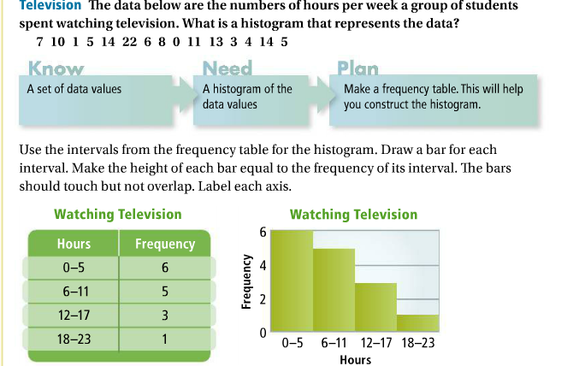 | - Frequency  - Histogram  - Frequency Table  - Uniform  - Skewed  - Symmetrical
Central Tendencies and Standard Deviation  Chapter 12 Section 3 | 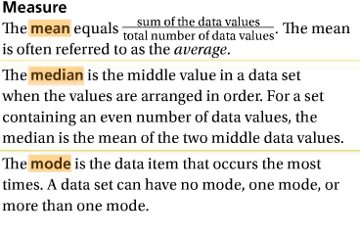  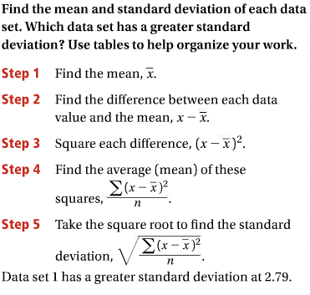 | - Mean  - Median  - Mode  - Standard Deviation  - Range  - Outlier
Box and Whisker  Chapter 12 Section 4 | 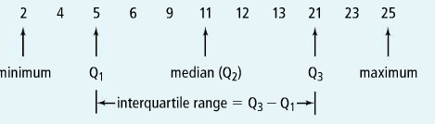  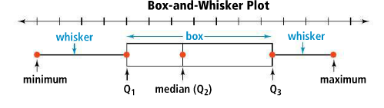 | - Quartiles  - Interquartile Ranges  - Median  - Maximum  - Minimum
Categorical Data | Text Message Instant Message Total  Boys 46 38  Girls 59 41  Total  Relative Frequency of Boys who text message  ^{46/184=25%} | - Categorical Table  - Relative Frequency  - Categorical Data  - Quantitative Data  - Conditional Relative Frequency

If you or your students have any questions about the unit or math class, feel free to contact me at hummelcl@qps.org or call 217-223-0373 Extension 1309

