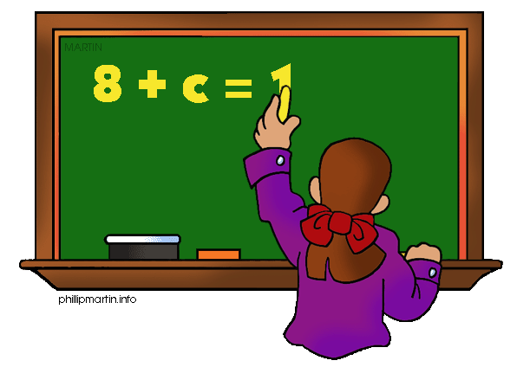
Math 7

Parents as Partners

What we are learning about: Unit 4 Geometry

One way you can help your student succeed in the unit is by discussing the lesson targets in the chart below. When a lesson is completed, ask your student the following questions:
- What are the targets (goals) of the lesson?
- What new words and formulas did you learn?
- How can you apply the ideas of the lesson to your life?

Target | Examples | Key Vocabulary
Scale Drawing  Chapter 7 Section 4 | 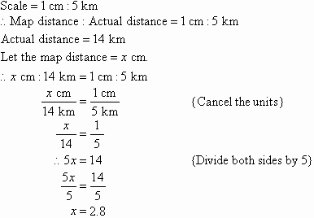 | - Scale  - Scale Drawing  - Scale Model  - Scale Factor
Classifying Angles  Chapter 7 Section 1 | 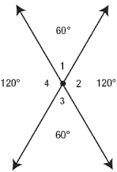  ^{1 and 2 are adjacent}  ^{1 and 3 are vertical} | - Acute  - Obtuse  - Straight Angle  - Vertical Angle  - Congruent Angle  - Adjacent Angle
Complementary and Supplementary Angles  Chapter 7 Section 2 | 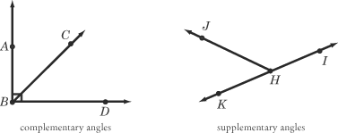 | - Complementary Angles  - Supplementary Angles  - Right Angle
Rules of Triangle  Chapter 7 Section 3 | 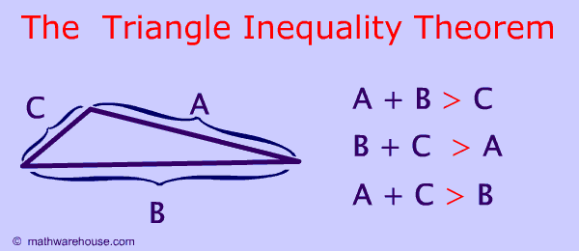  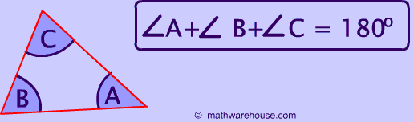 | - Side Inequality Theorem  - Sum of Angles Theorem
Circumference and Area of Circles  Chapter 8 Sect. 1,2 | 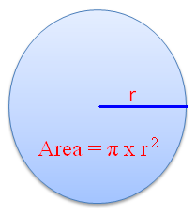  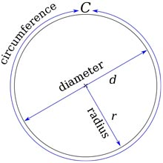  ^{C= 2 x r x π}  ^{C= d x π} | - Diameter  - Circumference  - Radius  - Pi  - Semicircle  - Area
Cross Sections of 3D shapes  Chapter 7 Section 6 | 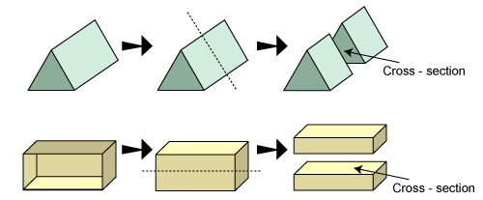 | - Cross Section  - Horizontal  - Vertical  - Base
Volume of Prism  Chapter 8 Section 4 | 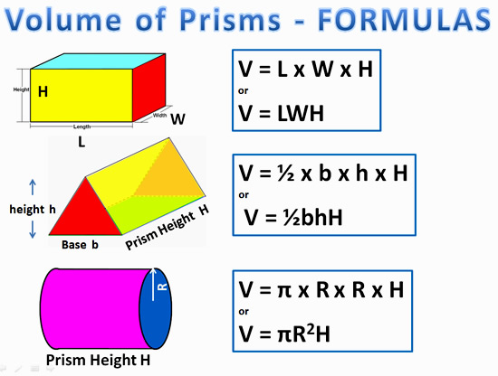 | - Prism  - Volume  - Length  - Width  - Height  - Cubic Units
Surface Area of Prisms  Chapter 8 Section 6 | 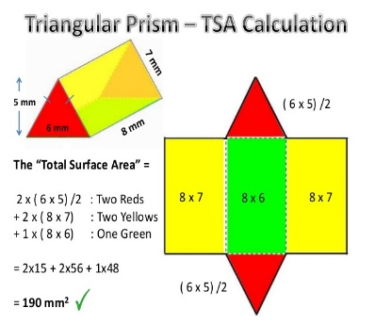  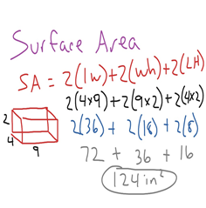 | - Prism  - Surface Area  - Length  - Width  - Height  - Square Units

If you or your students have any questions about the unit or math class, feel free to contact me at hummelcl@qps.org or call 217-223-0373 Extension 1309

