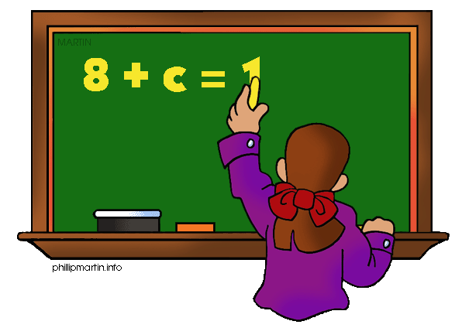
Parents as Partners
Algebra 1

What we are learning about: Unit 4 Systems of Equations and Inequalities

One way you can help your student succeed in the unit is by discussing the lesson targets in the chart below. When a lesson is completed, ask your student the following questions:
- What are the targets (goals) of the lesson?
- What new words and formulas did you learn?
- How can you apply the ideas of the lesson to your life?

Target | Examples | Key Vocabulary
Graphing Systems  Chapter 6 Section 1 | 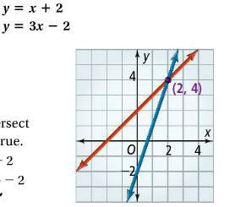 | - Slope Intercept Form  - Solution  - No Solutions  - All Real Numbers  - Slope  - Y intercept  - Ordered Pair
Systems by Substitution  Chapter 6 Section 2 | 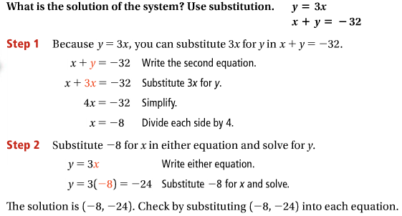 | - Substitution  - Ordered Pair  - X Coordinate  - Y Coordinate
Systems by Elimination  Chapter 6 Section 3 | 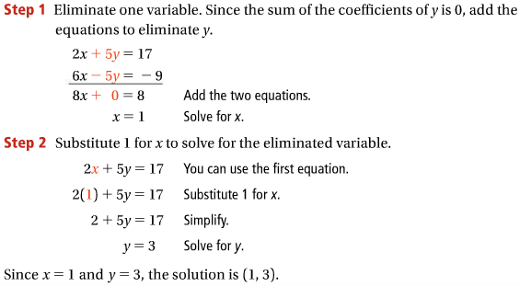 | - Elimination  - X Coordinate  - Y Coordinate  - Ordered Pair  - Substitution
Linear Inequality Systems  Chapter 6 Section 6 | 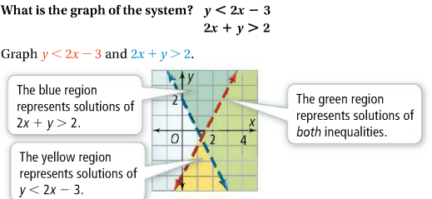 | - Inequality  - Slope  - Y-intercept  - Solution  - More than  - Less than

If you or your students have any questions about the unit or math class, feel free to contact me at hummelcl@qps.org or call 217-223-0373 Extension 1309

