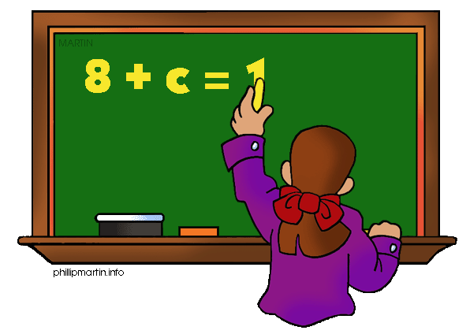
Parents as Partners
Algebra 1

What we are learning about: Unit 6 Exponent Rules and Growth and Decay Models

One way you can help your student succeed in the unit is by discussing the lesson targets in the chart below. When a lesson is completed, ask your student the following questions:
- What are the targets (goals) of the lesson?
- What new words and formulas did you learn?
- How can you apply the ideas of the lesson to your life?

Target | Examples | Key Vocabulary
Multiplication and Dividing Exponent Rules  Chapter 7 Section 2 and 3 | 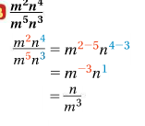 | - Exponent  - Base  - Difference  - Sum
Negative and Zero Exponents  Chapter 7 Section 1 | 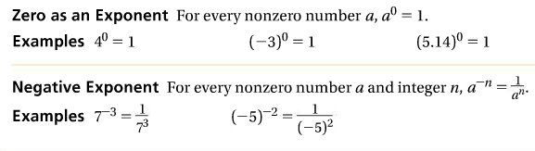 | - Reciprocal  - Exponent  - Base
Exponential Growth Models  Chapter 7 Section 5 | 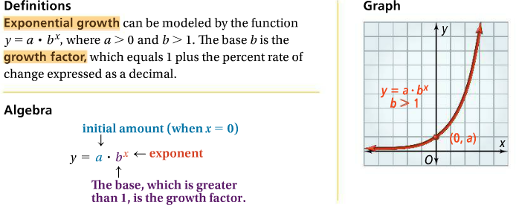 | - Exponential Growth  - Growth Rate  - Increase  - Growth Factor  - Compound Interest
Exponential Decay Models  Chapter 7 Section 6 | 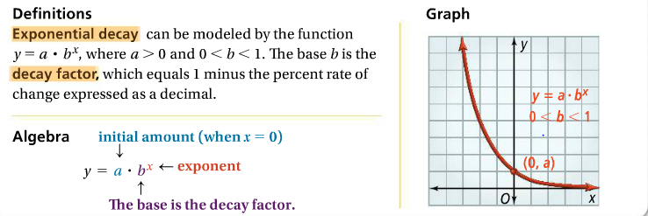 | - Decay Factor  - Exponential Decay  - Decrease  - Decay Rate  - Compound Interest

If you or your students have any questions about the unit or math class, feel free to contact me at hummelcl@qps.org or call 217-223-0373 Extension 1309

